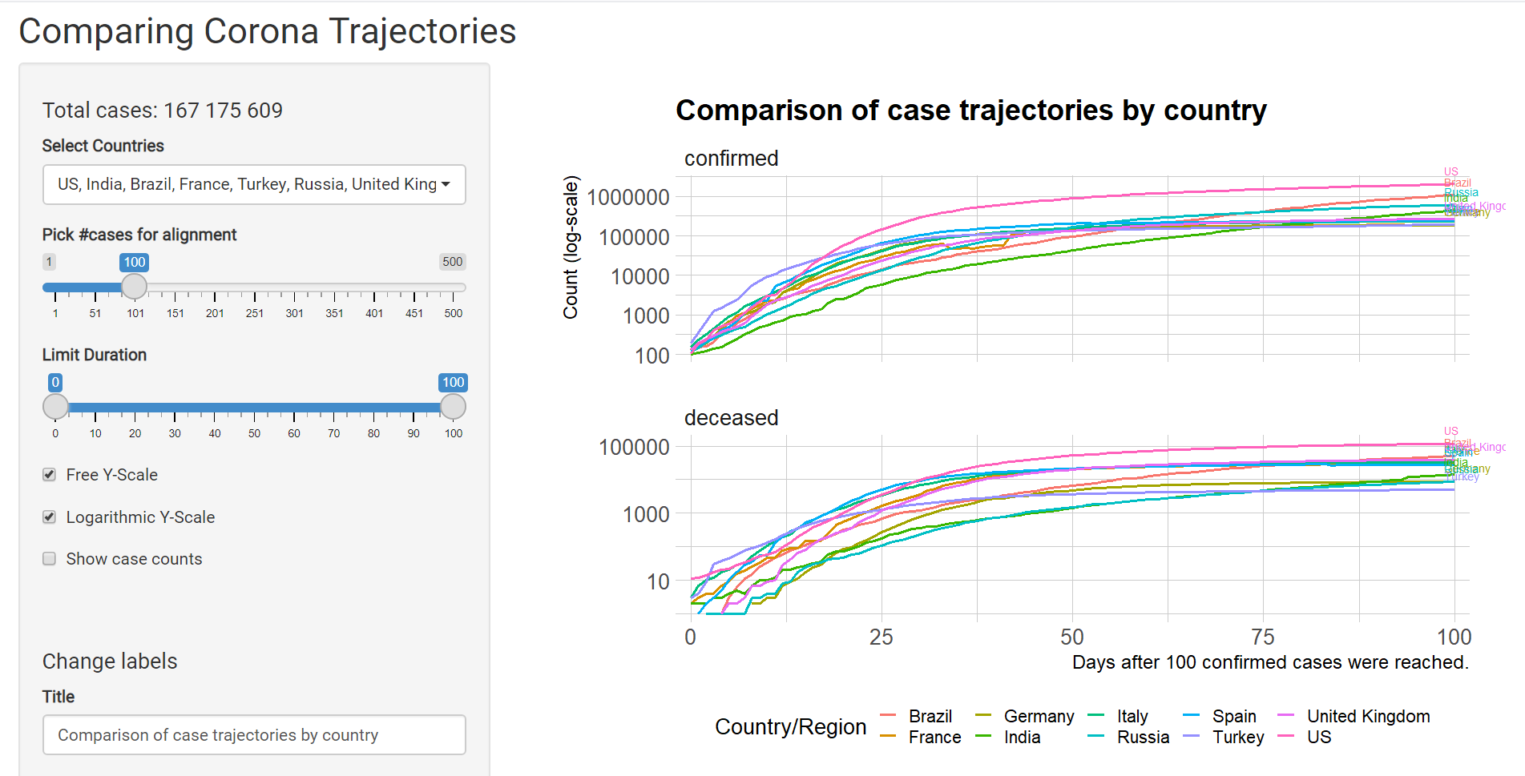

* The shiny App has features of:
  + Enables the users to select multiple countries of observance
  + # of cases for alignment signifies the projection after the number of cases reached
  + Limit Duration stands for the projection length
  + Enables the users to change the label of the graph
* Results:
  + Confirmed Cases:
    - In comparison to the initial stages of COVID-19 pandemic outbreak, the trajectory of predicted Confirmed Cases all have been reach plateau around 1,000,000 cases as the timeframe reaches 100 days. Although there are slight differences of rate at which the flattening occurs for each country, it is evident that the “flattening” occurs across all countries.
    - Most Prominent Cases of “Flattening”:

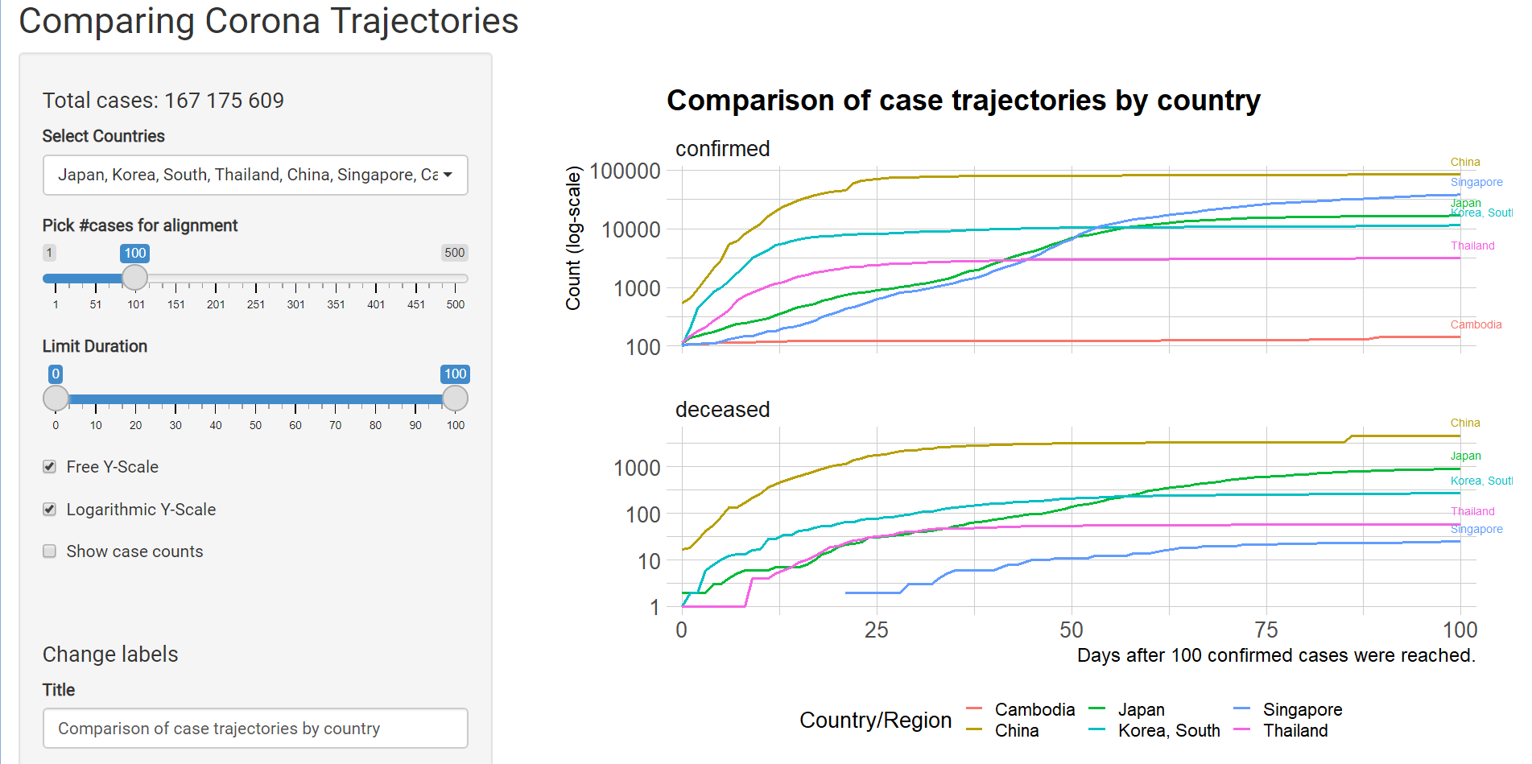

The Asian Countries listed: Japan, South Korea, Thailand, China, Singapore, and China, the “flattening” is ever so prominent. As one can see from the results above, due to the extensive “control” that the Asian countries have imposed upon the pandemic induced country, the flattening of Confirmed cases significantly flatten as the prediction reaches 100 days.